Tugas query 2

1.SELECT * FROM `obat`WHERE harga_obat >= 1000

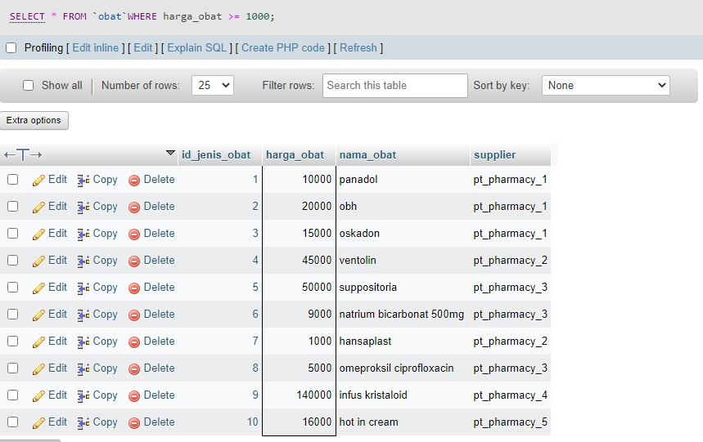

2. SELECT * FROM `obat`WHERE harga_obat > 1000

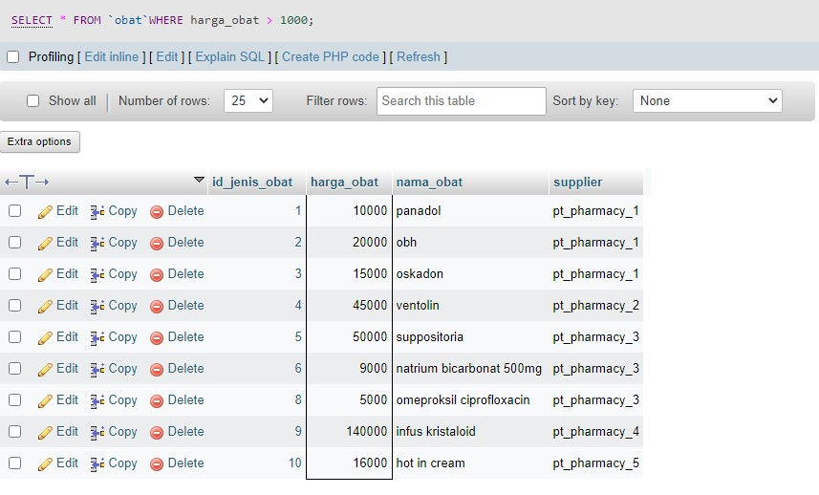

3. SELECT * FROM `obat`

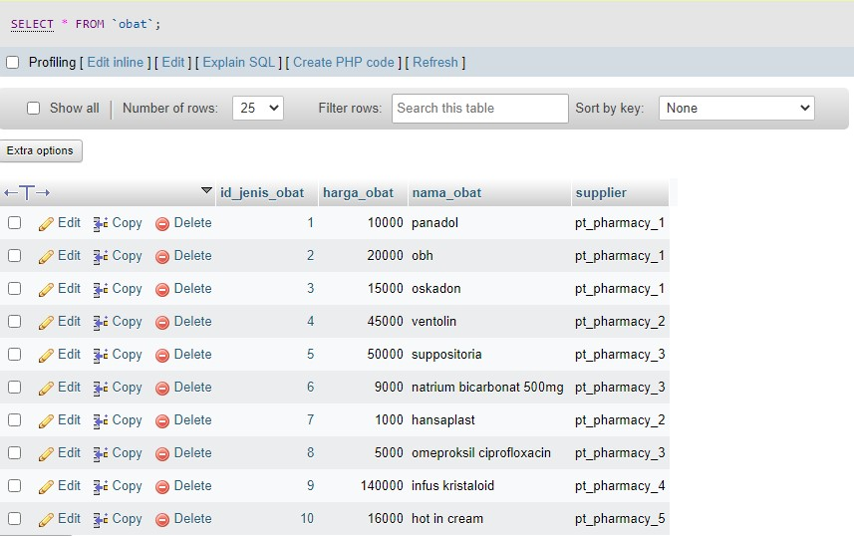

4. SELECT * FROM `obat` WHERE harga_obat < 10000

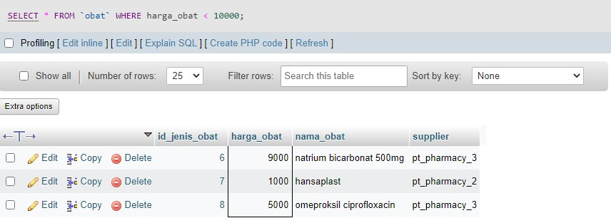

5. SELECT * FROM `obat` WHERE harga_obat <= 10000

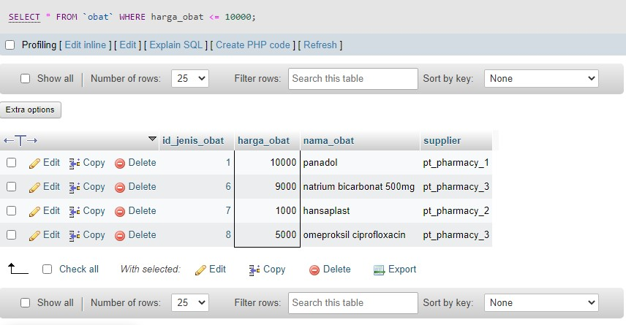

6. SELECT supplier FROM `obat`

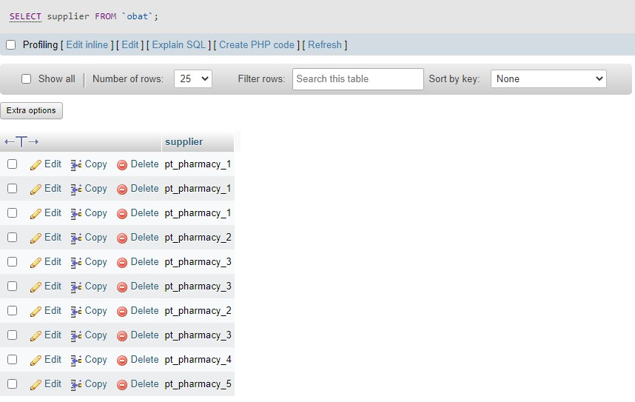

7. SELECT * FROM `obat` WHERE nama_obat LIKE '%obh%'

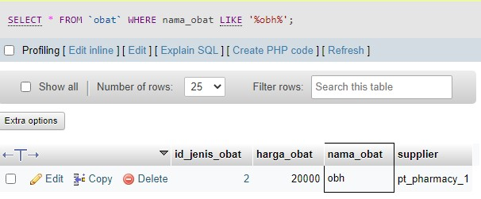

8. SELECT * FROM `obat` ORDER BY harga_obat DESC

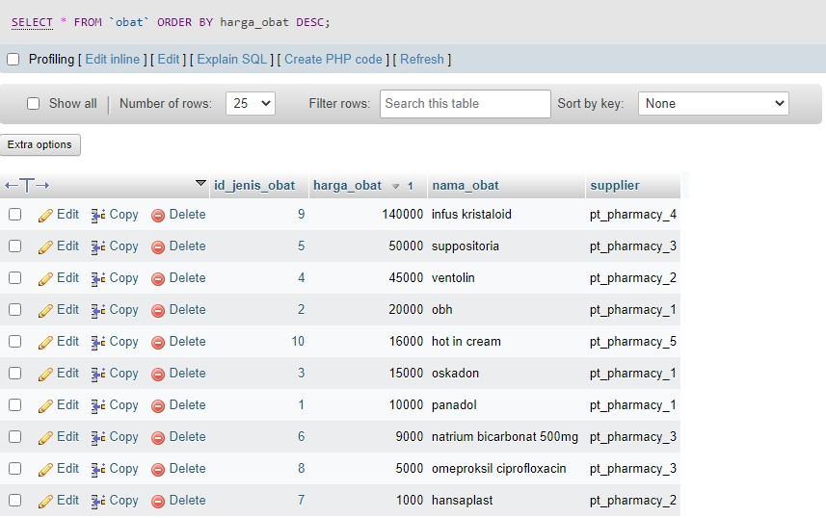

9. SELECT * FROM `obat` ORDER BY harga_obat ASC

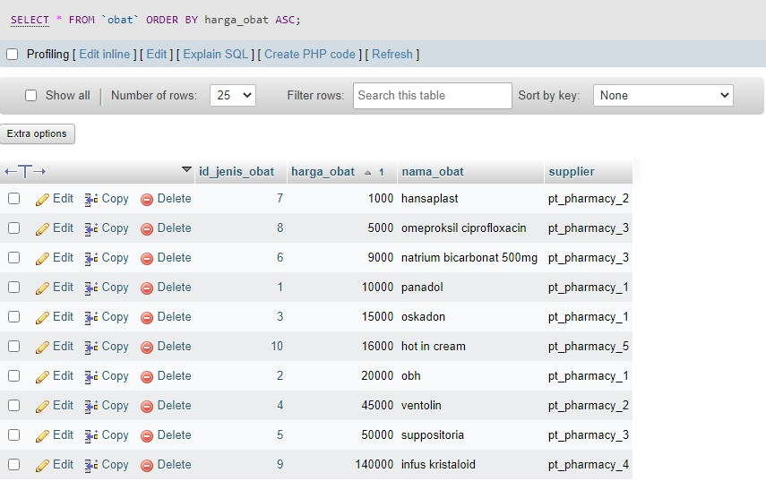

10. SELECT SUM(harga_obat) AS "obat" FROM obat

